Zooplankton drought paper

# Authors:

Arthur Barros

Rosemary Hartman

Sam Bashevkin

Christina Burdi

# Authorship Notes:

As you are working on this text, please:

* Insert figures in line with text
* Use word’s captioning and cross-reference tools
* I’m formatting references in End Note, so type in the citation, add the reference in a comment, and I’ll add it in later

This paper is one of a series of papers that came out of the Interagency Ecological Program Drought Synthesis Team. The team was formed in 2021 to respond to the extremely dry water year. The team analyzed impacts of drought on a broad suite of environmental parameters, from hydrology to water quality, to phytoplankton, to invertebrates, to fish. While there is no single agreed-upon definition for “drought”, droughts in California generally occur when there are multiple years of low precipitation and a resulting water supply shortage (DWR 2020). In this series of papers, the authors define “drought” as two or more consecutive years with a Sacramento Valley Index of Below Normal, Dry, or Critically Dry, similar to (Mahardja et al. 2021). “Wet” years are defined as two or more consecutive years with a Sacramento Valley Index of Above Normal or Wet. Each paper in this series can stand alone, but many of the papers refer to each other and provide complementary information.

# Introduction

As the primary consumers of phytoplankton within the San Francisco Estuary (SFE), zooplankton facilitate a vital trophic link between phytoplankton producers and higher-level consumers. In the SFE zooplankton are a key food source for several endangered and threatened species, notably the Delta Smelt (*Hypomesus transpacificus*), Longfin Smelt (*Spirinchus thaleichthys*) (Slater & Baxter 2014; Hobbs et al. 2006), and juvenile Chinook Salmon (Goertler et al. 2018).

Since the implementation of the CDFW Zooplankton Study in 1972, there has been a significant decrease in the overall abundance of zooplankton coinciding with the spread of *Potamocorbula amurensis* in the mid-1980s (Kimmerer et al. 1994; Carlton et al. 1990). Substantial changes in the zooplankton community composition and abundance in the SFE have been linked to major declines in the pelagic fishes of the upper estuary known as the “Pelagic Organism Decline” (Sommer et al. 2007; Winder & Jassby 2011). While abundance for several zooplankton groups has declined, important shifts in their communities have also occurred, driven by the introduction and spread of several non-native zooplankton species. Non-native zooplankton such as the cyclopoid copepod *Limnoithona tetraspina*, the mysid *Hyperacanthomysis longirostris,* and the calanoid copepod *Pseudodiaptomus forbesi* have all become abundant sources of food for fishes in the upper estuary (Barros 2021, Lojkovic Burris et al. 2022).

Historically, abundance of several important zooplankton species, such as *Neomysis mercedis* and *Eurytemora affinis* were positively correlated with outflow (Jassby et al. 1995, Kimmerer 2002). During drought years, outflow of freshwater can decrease drastically, and understanding how this impacts zooplankton populations is integral to making management decisions. One possible mechanism for how loss of outflow during drought years can impact zooplankton abundances is through changes in the location of the low-salinity zone (LSZ) (1 – 6ppt). Before the invasion of *P. amurensis*, positioning of the LSZ in the shallower areas of Suisun Bay during spring and summer led to higher levels of productivity due to higher water residence time and turbulent mixing (Cloern et al. 1983). The distribution and abundance of many zooplankton species can be strongly correlated to the distribution of salinity gradients across the estuary, based on each species salinity tolerances (Ambler et al. 1985, Hamilton et al. 2020).

It would be nice here to summarize the initial findings of the 2021 Drought MAST, have those been published anywhere we could cite?

To better understand how years of drought impact the abundance of zooplankton in the SFE, we examined three questions in relation to four important taxa in the region. 1) Do zooplankton abundances change regionally between drought and wet years? 2) Is salinity a reliable environmental parameter correlated with abundance? 3) Do drought years effect how salinity correlates with abundance? We used four abundant target taxa in our analysis: the cladocera *Daphnia spp.*, the mysid *Hyperacanthomysis longirostris*,the cyclopoid copepod *Limnoithona tetraspina*, and the calanoid copepod *Pseudodiaptomus forbesi*.

## Target Taxa

*Hyperacanthomysis longirostris* (formerly *Acanthomysis bowmani*), is a mysid shrimp native to the Ariake sea in Japan (Suzuki et al. 2009). It was first documented in the SFE in 1993, where it was most likely introduced in ballast water (Modlin and Orsi 1997). After its introduction, *H. longirostris* quickly became the most abundant mysid in the estuary, dominated catches of the CDFW Zooplankton Survey and Fall Midwater Trawl mysid trawls (Barros 2021; Avila and Hartman 2020). It is found throughout the upper estuary, and it appears to have higher temperature and salinity than the native mysid, Neomysis mercedis (Avila and Hartman 2020). *H. longirostris* is also smaller at maturity than N. mercedis (Avila and Hartman 2020). Abundance is usually highest in the summer (June-August), with lower abundances in fall, winter and spring (Barros 2021). This species has not been studied very frequently in the Estuary, but as the dominant mysid it most likely plays an important role in fish diets.

The introduced calanoid copepod *Pseudodiaptomus forbesi* was first detected in 1988, and quickly became the most abundant calanoid in the upper estuary, generally replacing the once abundant *Eurytemora affinis* as the primary copepod of choice for the endangered Delta Smelt (Moyle et al. 1992; Slater & Baxter 2014). Since its introduction *P. forbesi* soon became the numerically dominant calanoid in the estuary and remains the most abundant to this day (Barros 2021), shifting the peak timing of *E. affinis* earlier towards March and April, as compared to its previous peak in July (Merz et al. 2016). The introduction of the predatory calanoid copepod *Acartiella sinensis* in 1993 is hypothesized to have narrowed the range of *P. forbesi* away from the LSZ and towards the freshwater zone of the upper estuary due to its predation on *P. forbesi* nauplii*.* (Slaughter et al. 2016; Kayfetz & Kimmerer 2017).

# Methods

Zooplankton Catch Per Unit Effort (CPUE, organisms/m3) data was downloaded using the zooper package (<https://github.com/InteragencyEcologicalProgram/zooper>), an R package that synthesizes zooplankton data from multiple IEP studies. Using R we joined CPUE data for macro (500-505 μm mesh), meso (150-160 μm mesh), and micro (43 μm mesh) nets into one data frame. We then joined biomass lookup data for meso (*P. forbesi* and *Daphnia spp.)* and micro zooplankton (*L. tetraspina*), which use fixed biomass conversions for each ~~taxa~~ taxon (BPUE, μg/m3). BPUE for macro zooplankton (*H. longirostris*) was calculated using length-weight equations. Sampling data used in analysis excluded winter months (December – February) due to historical inconsistency in winter sampling. Samples were then filtered to include data from 1994-2021, the period in which all examined taxa were present in the estuary.

Sampling stations were assigned to regions based on the R_EDSM_Subregions_Mahardja shapefile from the Deltamapr package (Bashevkin 2021), and data from the “North” was excluded due to lack of consistent long-term zooplankton sampling in the region. The four regions examined in this study were Suisun Marsh, Suisun Bay, the confluence of the Sacramento and San Joaquin Rivers (Confluence), and the South Central Delta.

For all samples the water year was calculated for each sample so that water year X = December (X-1) – November X. Water years were then categorized as “Drought” for multiple dry, below normal, or critically dry years in a row, and “Wet Period” for multiple wet or above average years in a row.

## Modeling

To analyze regional abundance differences between drought and wet years BPUE data for each of the four taxa examined was averaged for each region and year. Then, for each taxon and region combination, analysis of variance was conducted on the natural log-transformed yearly BPUE averages for each year type (drought vs. wet). Due to the abundance of all taxa examined being highest during the warmer months, we filtered our analysis to only examine samples collected from May through November of each year.

To examine the effect salinity has on the BPUE of the four taxa, generalized additive models (GAM) were done for sample BPUE and salinity data using the mgcv R package (v1.8-34; Wood, 2011). For each taxa, two different GAMs were run due to the high presence of zero abundances in our sampling effort. The first model for each taxon was a presence/absence binomial GAM, while the second model was a BPUE negative-binomial GAM, using only samples that had a presence of the target taxon. For all the taxa the binomial model was:

$m1: Presence \sim f(salinity)$

While for all the taxa except Daphnia, the second model was:

$$m2:\ln\left(BPUE \right)\sim f\left(salinity+month\right)$$

Because of regional differences in the abundance of Daphnia between the Sacramento River and the San Joaquin River, we included station as a random effect in its abundance model:

$m2 (Daphnia):\ln\left(BPUE\right)\sim f(salinity+month+station|1$)

For each taxon, the model predictions were generated for each of the two models, multiplied together, and plotted with 95% confidence intervals to visualize trends.

To determine if drought impacted how salinity correlated with BPUE, we first calculated each taxa’s ‘preferred’ salinity range. We calculated the mean salinity range for each taxon, weighted by BPUE, as well as the standard deviation. The ‘preferred’ salinity range of each taxon was then noted as the weighted mean ± the standard deviation. An ANOVA was then run to determine if there were any significant differences in the BPUE of a target taxon between drought and wet years, limited to only samples collected within that taxa’s ‘preferred’ salinity zone. Finally, we plotted the distribution of each taxa’s preferred salinity zone across the estuary during drought and wet years to further examine how these zones changed across the estuary.

# Results

## Regional Changes

Several significant differences in taxa BPUE were found between Drought and Wet years (Figure 1), however not all taxa showed this relationship, and not in all regions. The abundance of *Daphnia spp.* significantly decreased in the Suisun Marsh and Suisun Bay regions during Drought years but didn’t see any significant changes in upstream regions. The invasive cyclopoid *L. tetraspina* saw very large increases during Drought years in Suisun Marsh and the Confluence, while the mysid *H. longirostris* was the only taxon that saw no significant changes from Drought. The calanoid copepod *P. forbesi* saw significant changes in abundance during Drought years in each region, increasing in its upstream distribution and decreasing in the downstream, more brackish Suisun Marsh and Suisun Bay.

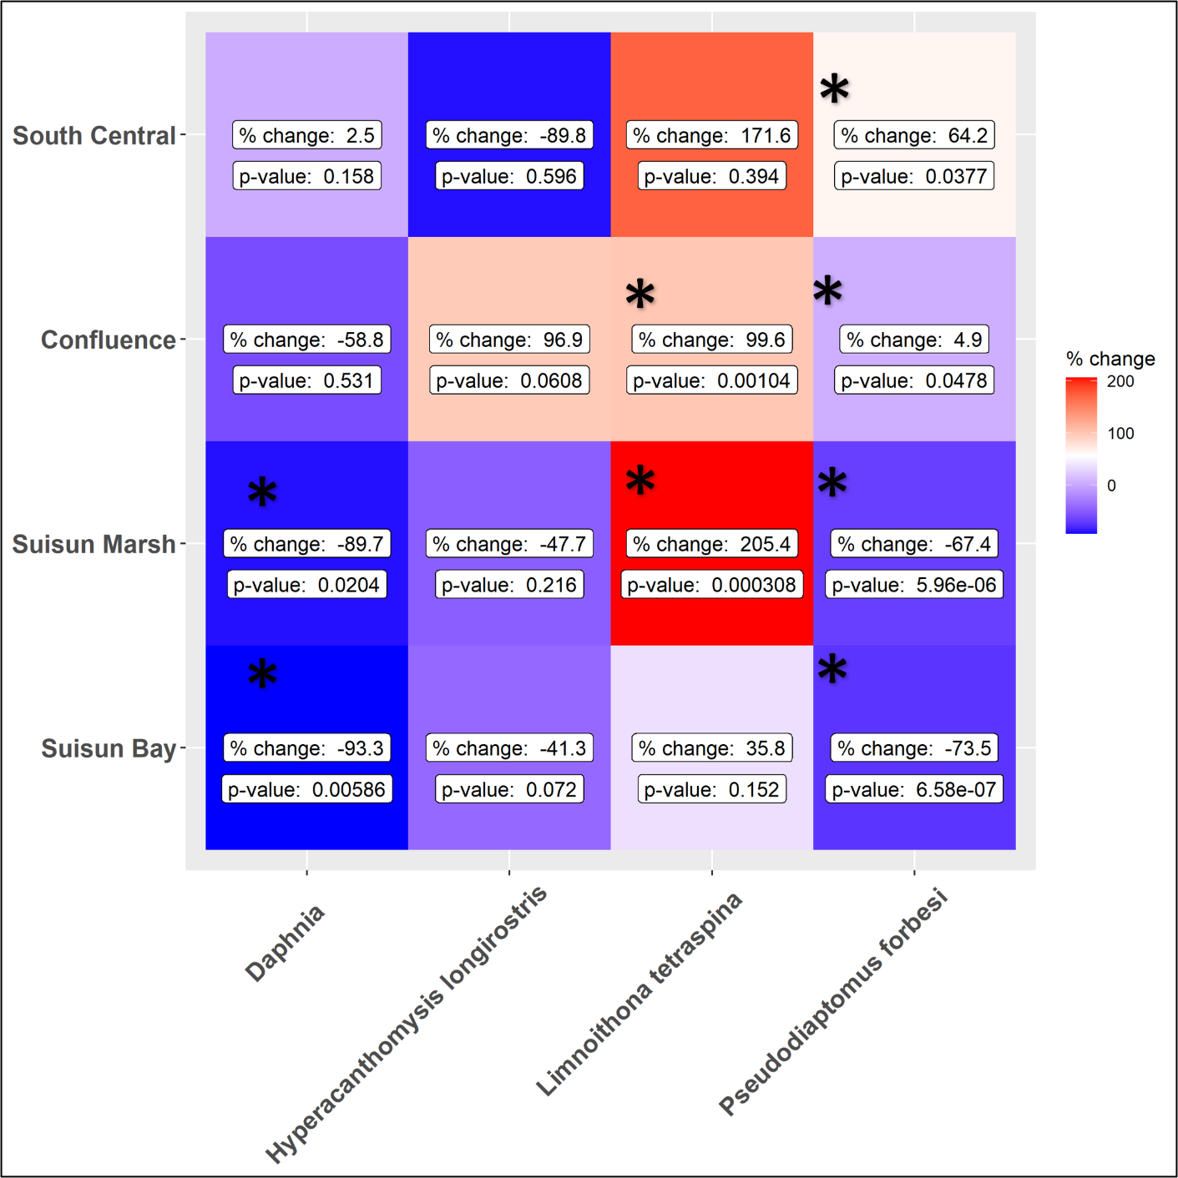

Figure Changes in average annual BPUE for target taxa and each analyzed region. Percent change shown represents the average change in BPUE from Wet to Drought years. Red shading represents an increase, blue shading represents a decrease in abundance.

## Environmental Parameters

Salinity was a significant factor in predicting the abundance of all taxa in the study area (Table 1). *Daphnia spp.* seemed to have the highest impact to presence and abundance from salinity (adjusted r2 = 0.239) of all the taxa, likely because of its restriction in the narrow freshwater range (Figure 2). While the presence of *P. forbesi* has a weaker correlation with salinity, and was found from fresh-water through the LSZ, its highest abundances were in the freshwater range of the estuary. Both *H. longirostris* and *L. tetraspina* had a wide salinity range correlated with higher abundances that stretched across the low-salinity zone.

Table Model outputs for each taxa.

|  |  |  |  |
| --- | --- | --- | --- |
| **Taxa** | **Model** | **P-value** | **R-sq.(adj)** |
| *Daphnia spp.* | Presence ~ s(salinity) | <2e-16 | 0.239 |
| *Daphnia spp.* | BPUE ~ s(salinity) + s(month, k = 5) + s(Station, bs = "re") | <2e-16 | 0.161 |
| *H. longirostris* | Presence ~ s(salinity) | <2e-16 | 0.035 |
| *H. longirostris* | BPUE ~ s(salinity) + s(month, k = 5) | <2e-16 | 0.0634 |
| *L. tetraspina* | Presence ~ s(salinity) | <2e-16 | 0.0248 |
| *L. tetraspina* | BPUE ~ s(salinity) + s(month, k = 5) | <2e-16 | 0.351 |
| *P. forbesi* | Presence ~ s(salinity) | 0.00119 | 0.0353 |
| *P. forbesi* | BPUE ~ s(salinity) + s(month, k = 5) | <2e-16 | 0.184 |

Figure Model predictions for the combined presence/absence and abundance models for all four taxa.

## Drought and Salinity Zones

*Daphnia spp.* had the smallest range of ‘preferred’ salinity, with its highest abundances being present in salinities below 0.5 ppt (Figure 3). *P. forbesi* also was most abundant in fresh water up to a salinity of 1.8 ppt. Both *L. tetraspina* and *H. longirostris* had their highest abundances in the brackish waters of the estuary.

Figure Salinity zones with highest abundance for each target taxa.

Within their ‘preferred’ salinity zone, only *L. tetraspina* saw significant changes, increasing in abundance during Drought years (Table 2, Figure 4). The other three taxa saw no significant changes in average annual BPUE within their ‘preferred’ salinity range during Drought years.

Table AOV models and Tukey HSD comparisons for each taxon's abundance between Drought and Wet years within their ‘preferred’ salinity zones.

|  |  |  |  |
| --- | --- | --- | --- |
| **Taxa** | **Preferred Salinity Zone** | **Model** | **W-D Tukey p-value** |
| Daphnia | 0-0.5 ppt | aov(log(BPUE + 1) ~ Drought) | 0.5612784 |
| H. longirostris | 3.2 – 6.7 ppt | aov(log(BPUE + 1) ~ Drought) | 0.309038 |
| L. tetraspina | 1.6 – 9.1 ppt | aov(log(BPUE + 1) ~ Drought) | **0.0055199** |
| P. forbesi | 0 – 1.8 ppt | aov(log(BPUE + 1) ~ Drought) | 0.3829747 |

Figure Boxplots of each taxon’s average annual BPUE within their 'preferred' salinity zone for Drought and Wet years.

Both *Daphnia spp.* and *P. forbesi* saw their ‘preferred’ salinity zone shrink during Drought years, shifting that salinity zone out of Suisun and into the West Delta (Figure 5). *L. tetraspina* and *H. longirostris* saw little change in their brackish ‘preferred’ salinity zones, which stayed located around the Suisun region during both Wet and Drought years.

Figure Spatial distribution of each taxa's 'preferred' salinity zone for Drought and Wet years. Vertical dashed lines represent the up and downstream extents of the study area. X-axis represents distance (km) from the Golden Gate bridge.

# Discussion

Assessing how zooplankton resources available to fish are affected by drought conditions is increasingly valuable for environmental managers in the SFE. While initial analysis of the impacts of drought on zooplankton abundance did not show significant changes at a coarse level, analysis at the regional level did show significant effects (Drought MAST Short-term Report). To further investigate this relationship, we narrowed our focus to specific key zooplankton taxa, their abundance correlation to salinity, and how that potentially fluctuated between drought and wet years. In drought years, *Daphnia spp.* saw significant decreases in abundance downstream in the Suisun Marsh and Suisun Bay. *Pseudodiaptomus forbesi* saw significant decreases downstream as well, although it also had significant increases in abundance upstream in the South-Central Delta during drought years. The more recently introduce *Limnoithona tetraspina* only saw increases in abundance during drought years, specifically in the Suisun Marsh and Confluence. The mysid *Hyperacanthomysis longirostris* was the only taxon of the four that showed no significant changes in abundance related to drought conditions.

Our modeling showed that the presence and abundance of the four taxa we investigated had significant correlation with salinity. Both *H. longirostris* and *L. tetraspina* had high probability of presence and high abundance within a wide range of salinity values spanning the LSZ, while *Daphnia spp.* and *P. forbesi* were both more limited to the freshwater reaches of the estuary. By showing how the preferred salinity zone of each taxa shifted upstream during drought year, especially for *P. forbesi* and *Daphnia spp.*, we can conclude that the change in that ‘preferred’ salinity zone distribution is tied to regional increases or decreases in the abundance of those taxa. During drought years, the preferred salinity zone of *P. forbesi* shifts out of Suisun, where we see a decrease in their abundance, and stays upstream in the Delta, where we see an increase in their abundance. Similarly, *Daphnia* spp. have their ‘preferred’ salinity zone narrow during drought years, and we see a large and significant decrease in their abundance downstream.

This same relationship between spatial changes in the ‘preferred’ salinity zone and abundance during drought years was not observed for either *L. tetraspina* or *H. longirostris*. *L. tetraspina* was the only one of the taxa examined that showed a significant, though slight, increase in abundance within its ‘preferred’ salinity zone. Also, while *L. tetraspina* did see a large increase in abundance within Suisun Marsh during drought years, its preferred salinity zone stayed centered around the downstream Suisun regions during both drought and wet years, and this same increase in abundance was not seen in Suisun Bay. The increase in *L. tetraspina* within its ‘preferred’ salinity zone during drought years could be connected to unexamined changes in the abundance of the predatory calanoid *Acartiella sinensis*, which is known to feed upon the cyclopoid (Slaughter et al. 2016). *H. longirostris*, the only species with no significant regional changes in abundance between drought and wet years, also saw no major spatial shifting of its preferred salinity zone.